**Exhaustive Analysis of Indian Agriculture Sector Using Power BI**

Power BI Desktop is your go-to tool for creating stunning data visualizations and interactive reports.

Start with a Blank Report:

* Blank Report: Start with a clean slate and build your report from scratch.

* Get Data from Other Sources: Connect to various data sources, including cloud databases, web services, and more.

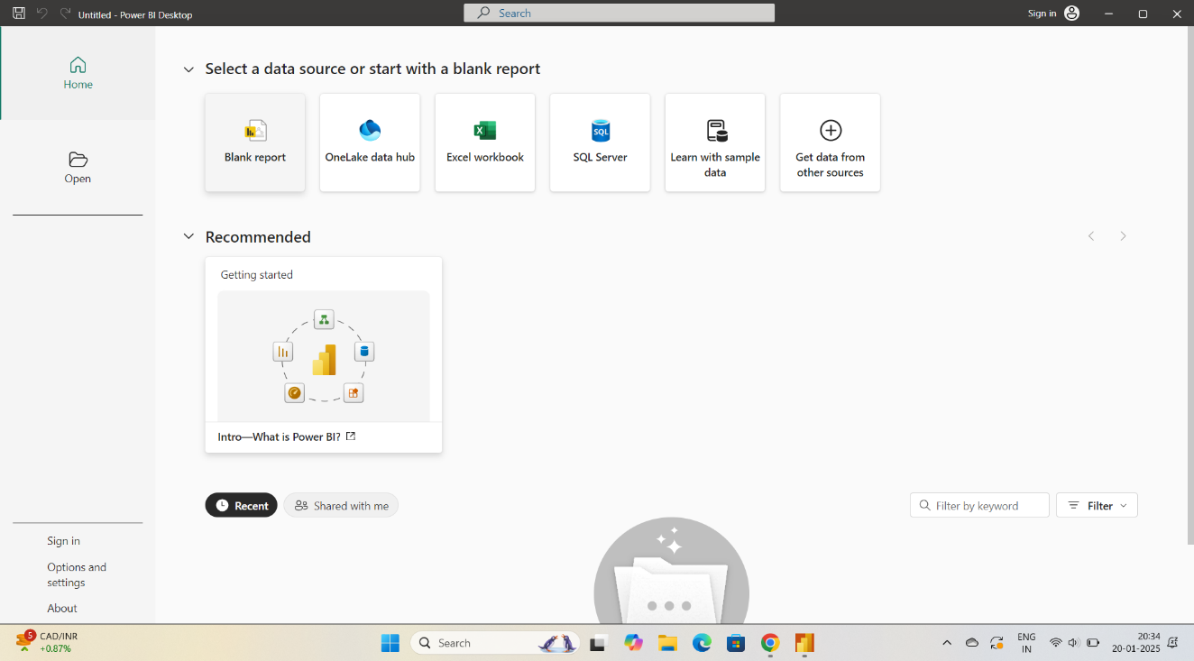

After selecting blank report, this page will appear. Later ,click on get data option.

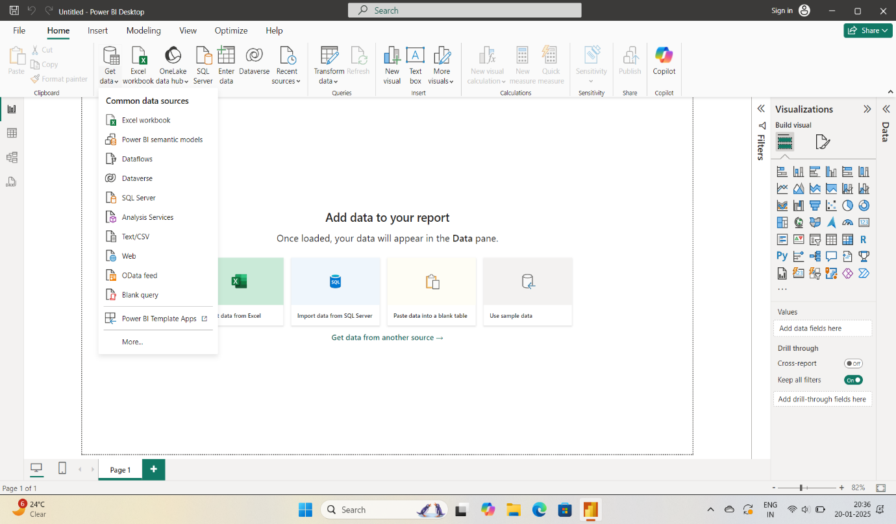

By clicking on get data we can see many options. Choose Text/csv

Option. 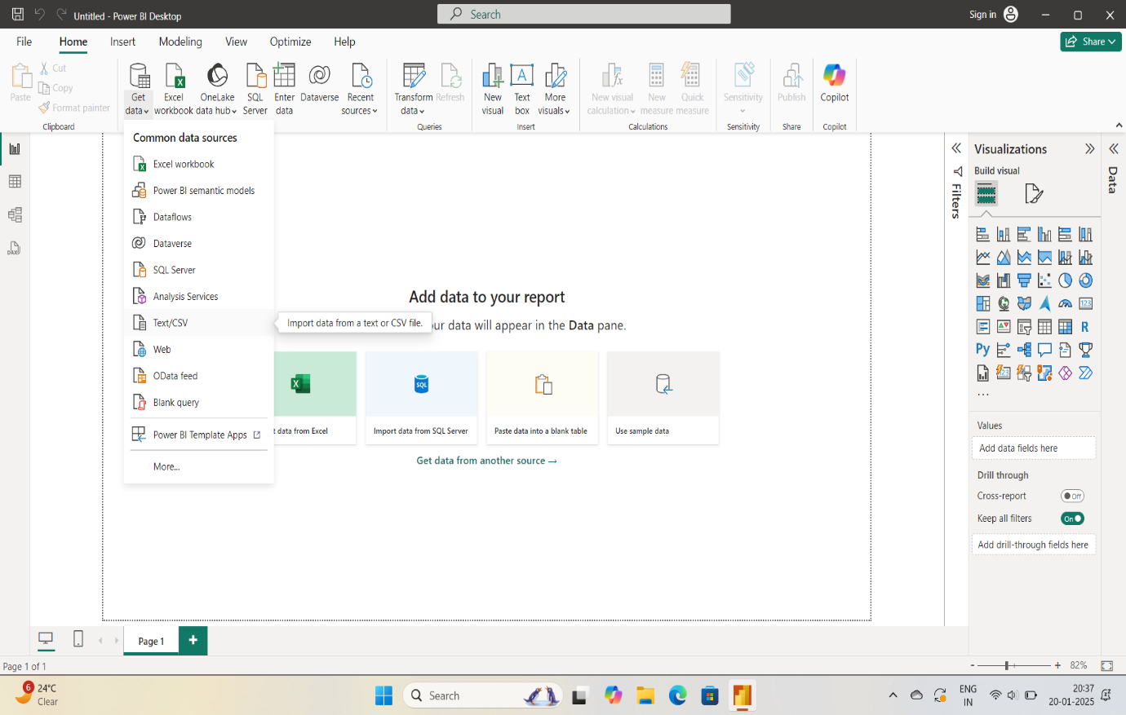

After clicking Text/CSV option ,file folder will opened .Now we have to choose our dataset file from our desktop. 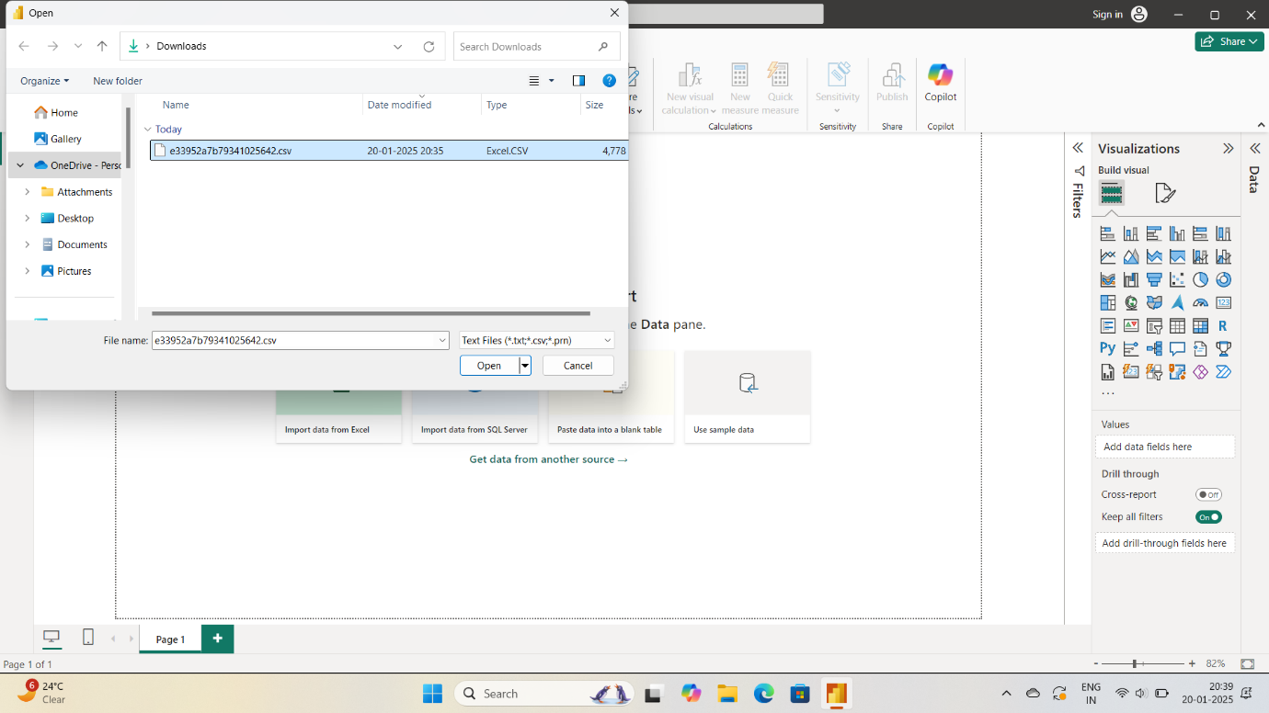

After choosing file folder , the data present in the CSV file will appear on our system.

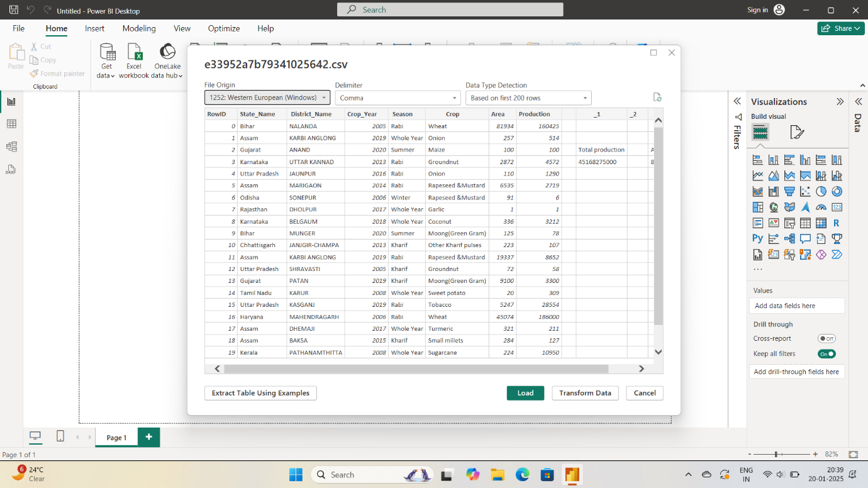

Click on Load button to store this file data in power BI desktop.



Later on ,it’ll appear on the screen .

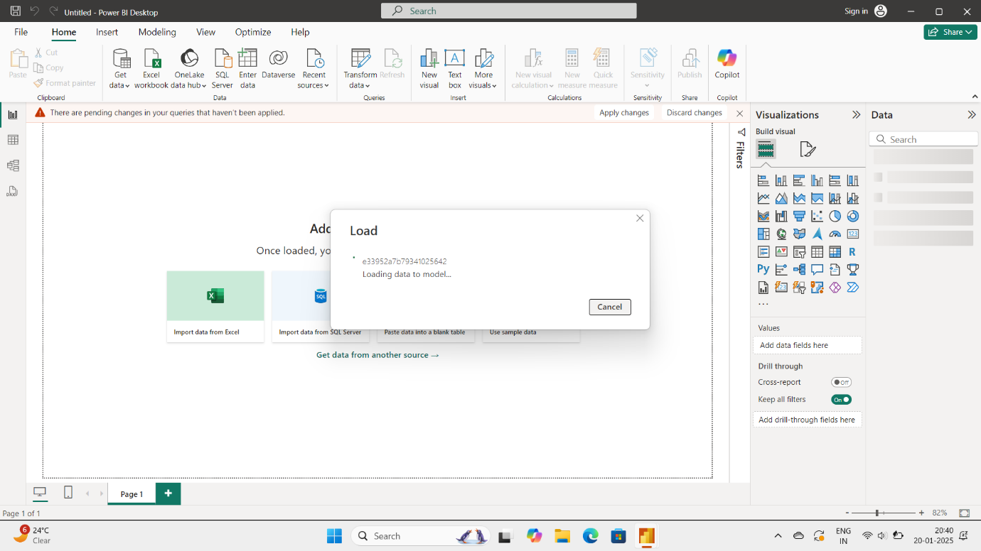

After Load the data , this page will be open . With that CSV file , We have to perform operations that are available in power BI.

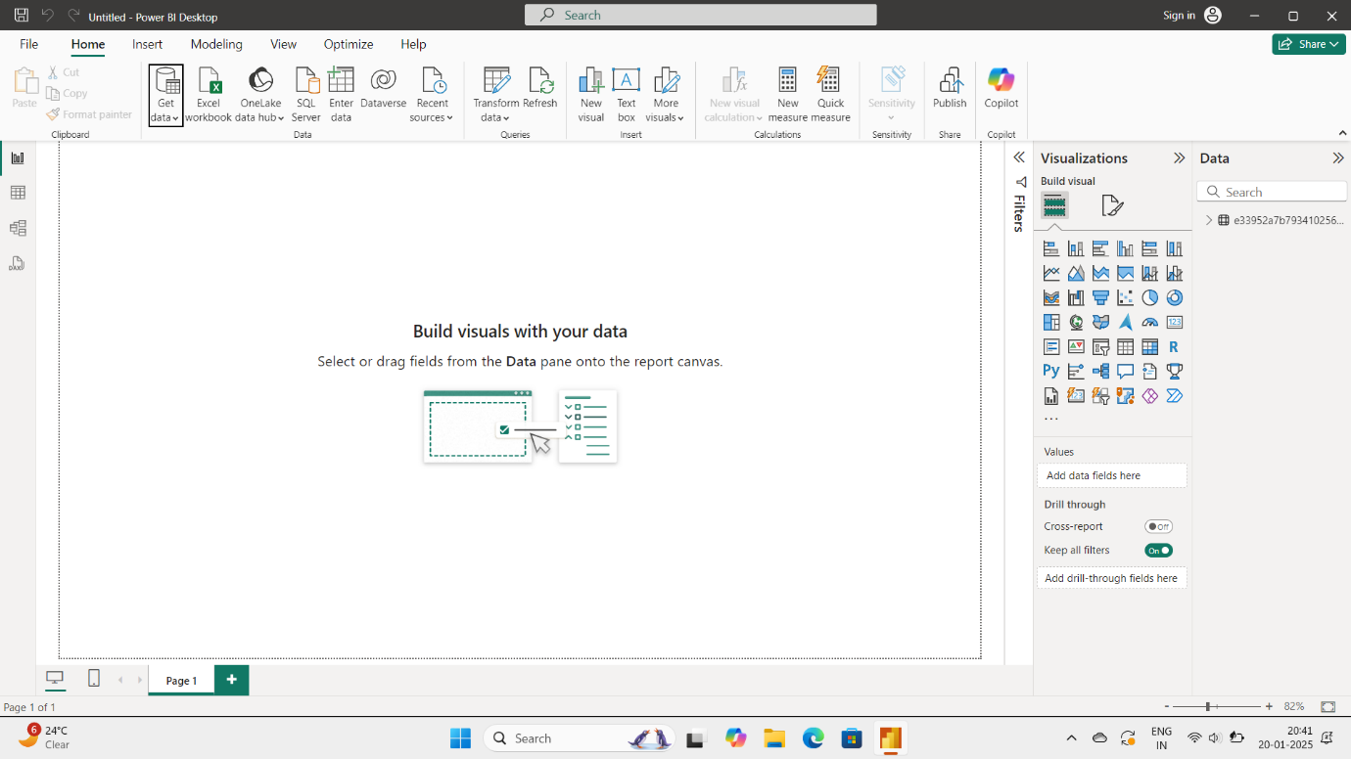

In this page , on the far left of the screen we can see 3 views which are used to manipulate the data as we need.

The first symbol is report view.

Report view : This is for Data Visualization.

Report view is used to represent the data in various formats such

as piecharts , Bargraphs , Histogram , Heatmaps , Scatterplots.

Report view transforms the data for better understanding.

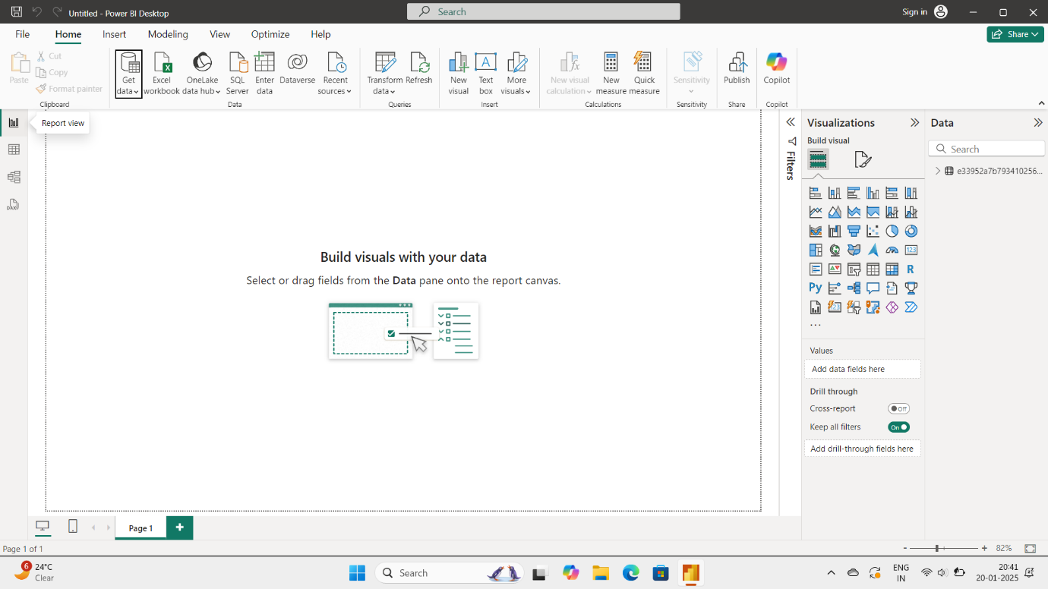

The second symbol is table view.

Table view : It will show our dataset.

Table view transforms the data which is in non-tabular format into

tabular form.

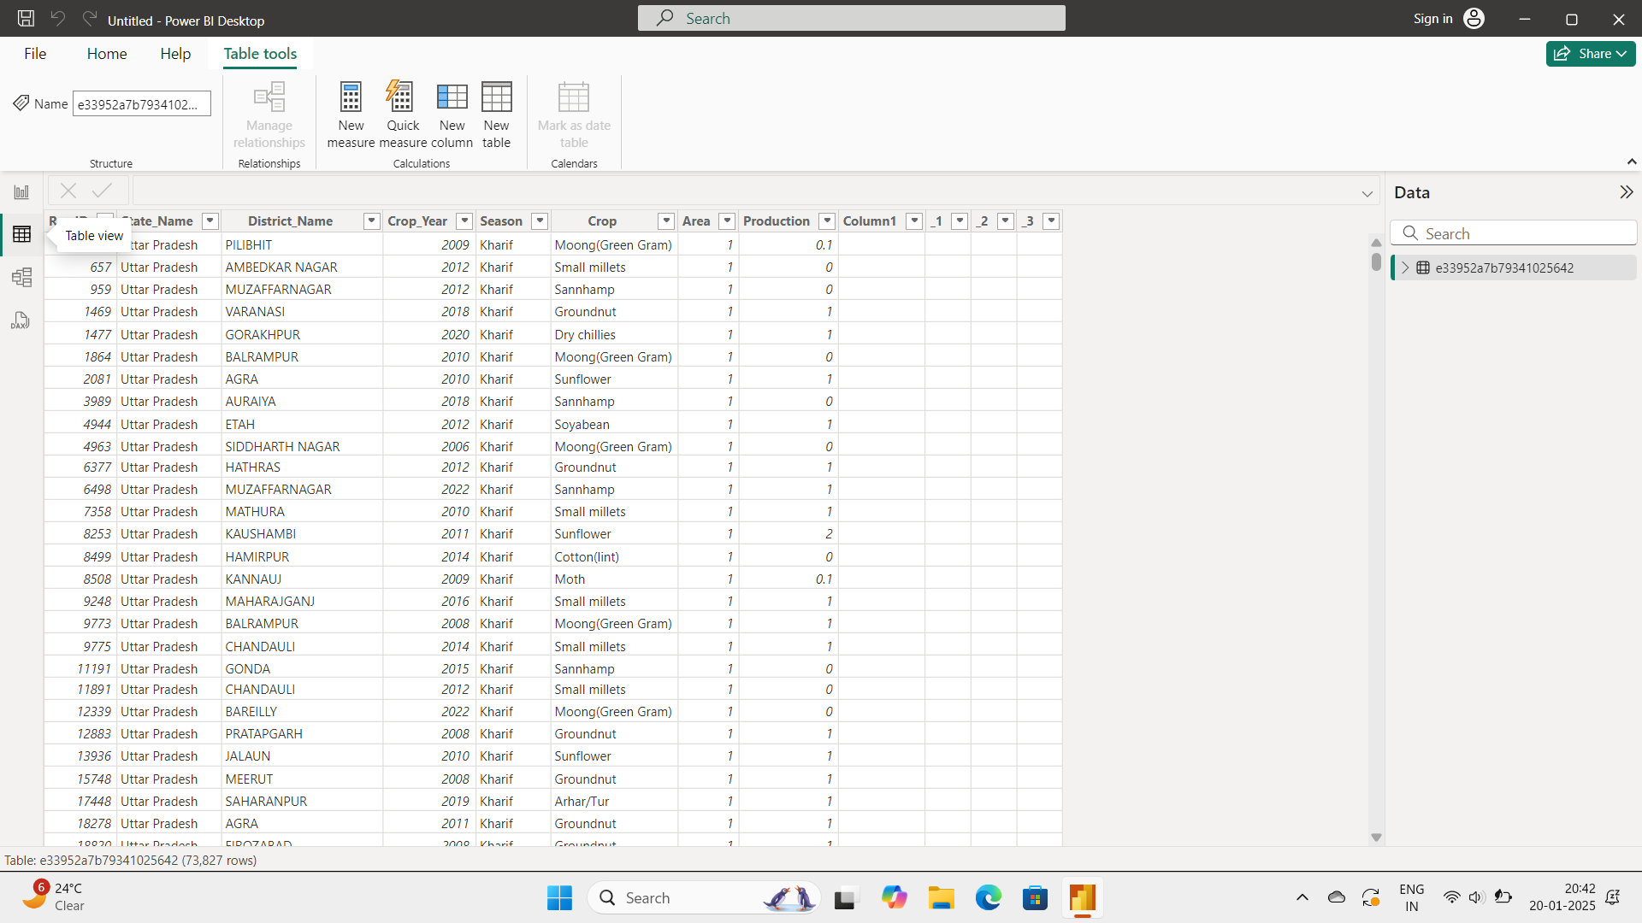

The third symbol is model view:

Model view : In this, we can create relationship among the data.

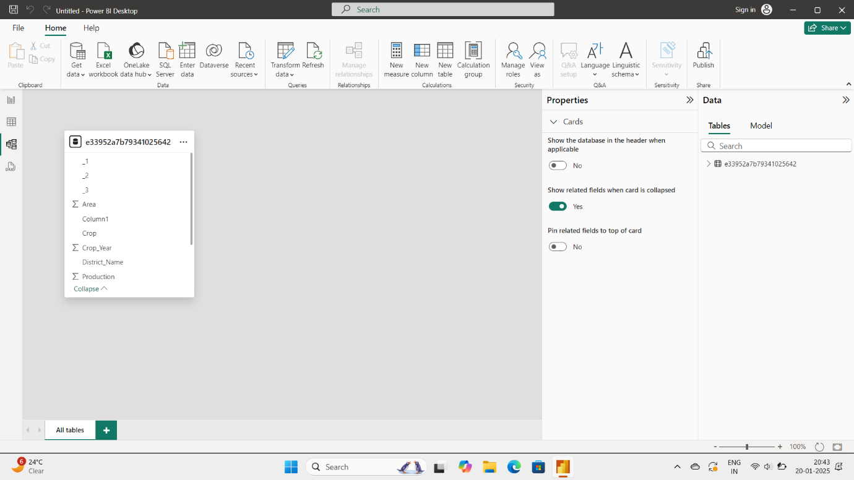

Now , Click on transform data button and select Transform data option.

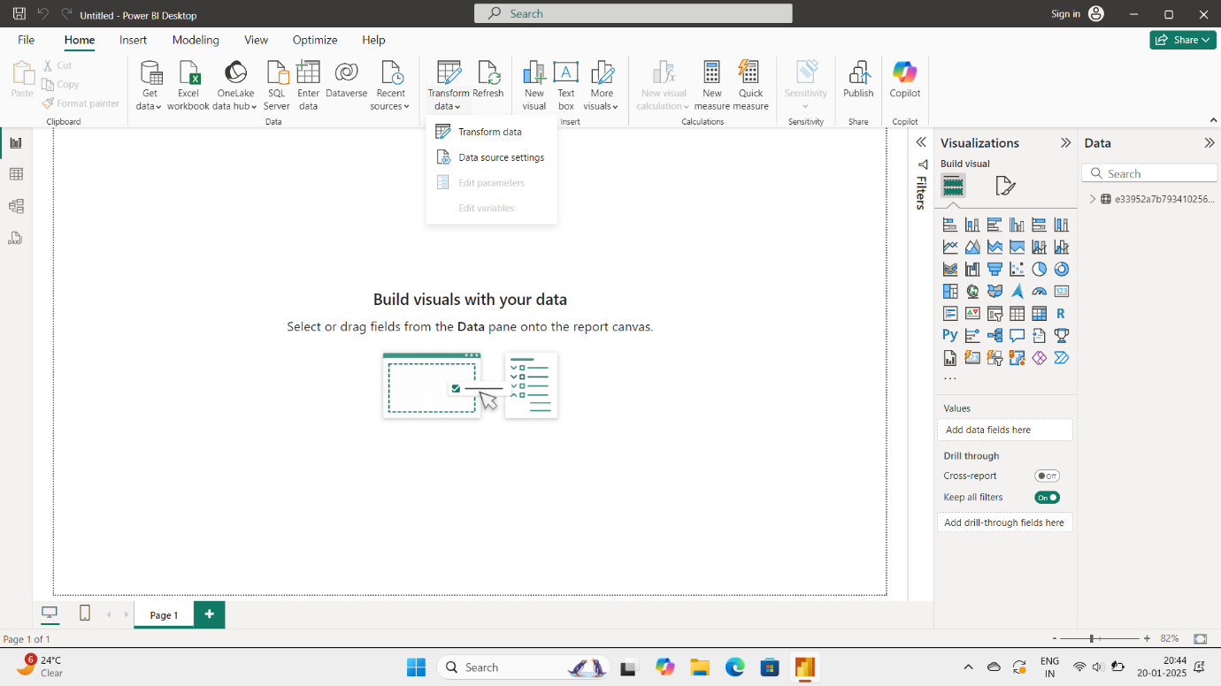

After clicking transform data , Our dataset will appear.

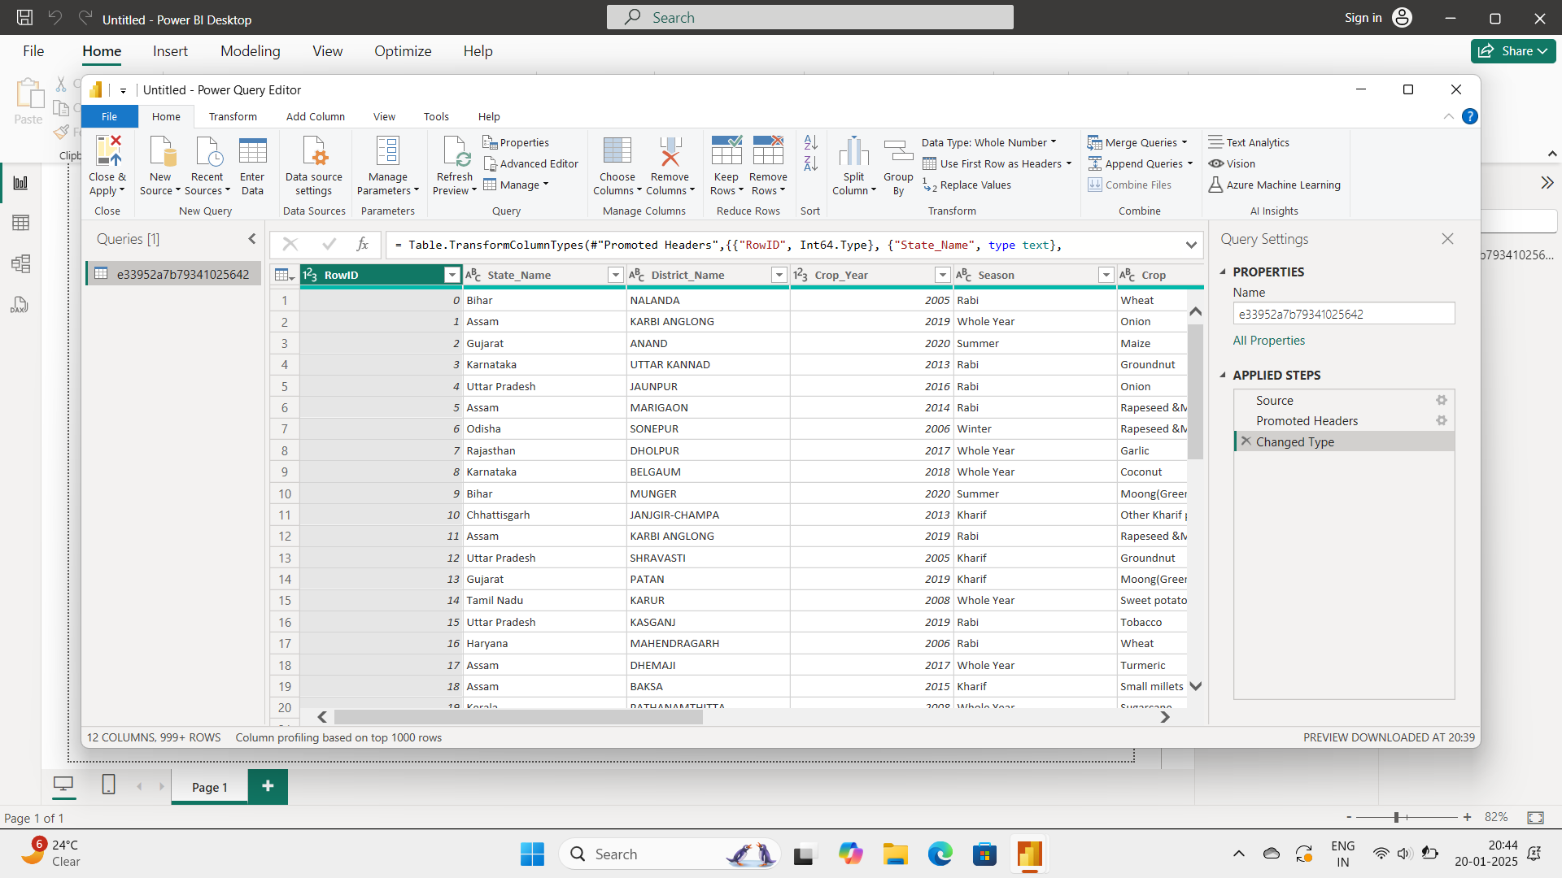

At the top , select remove columns option.

It will remove any of the selected columns from the dataset.

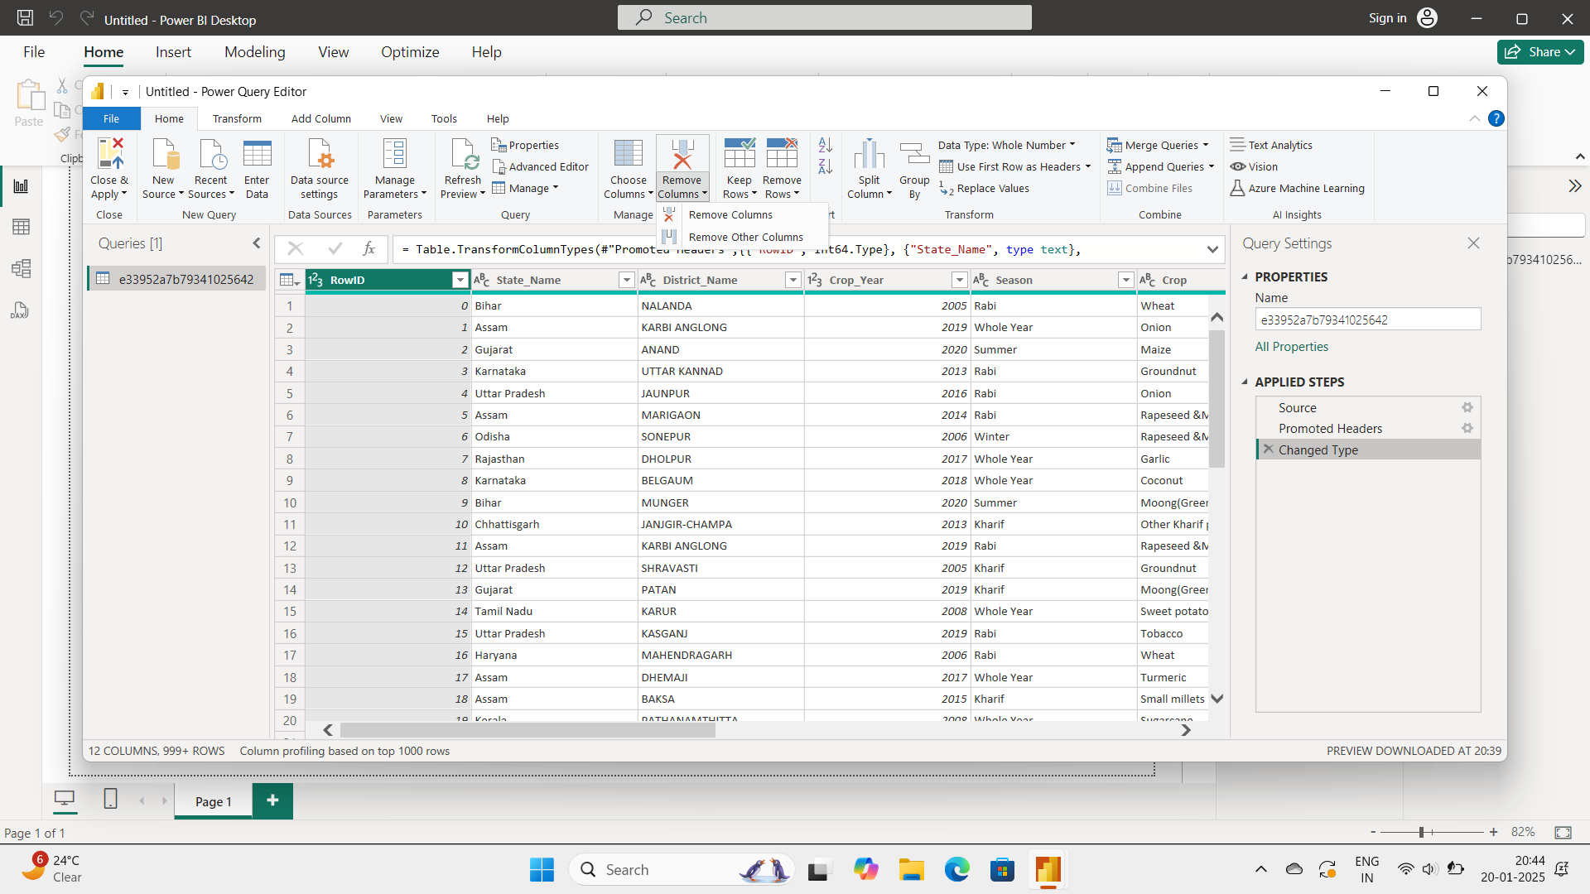

If we select any attribute , then the corresponding column is removed .

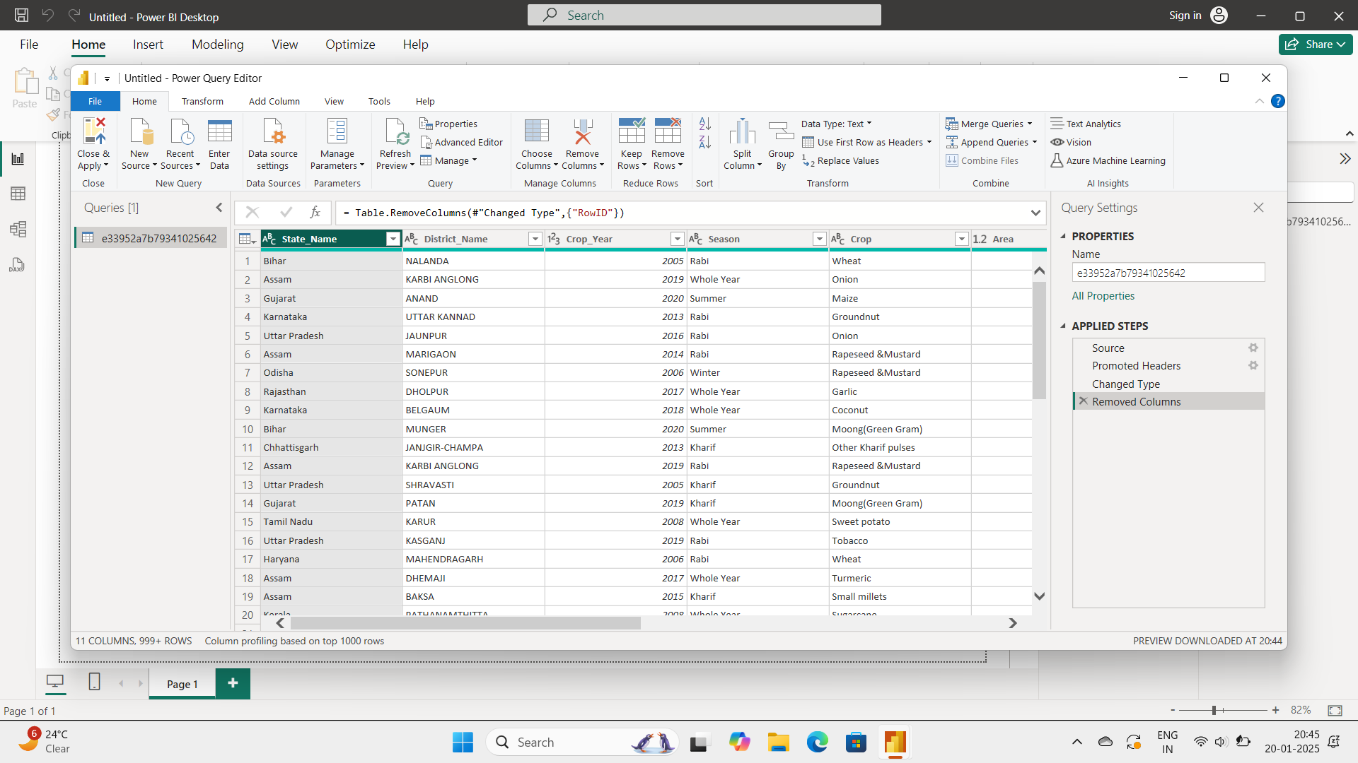

By clicking on button , it’ll undo the removed column to its previous positon.

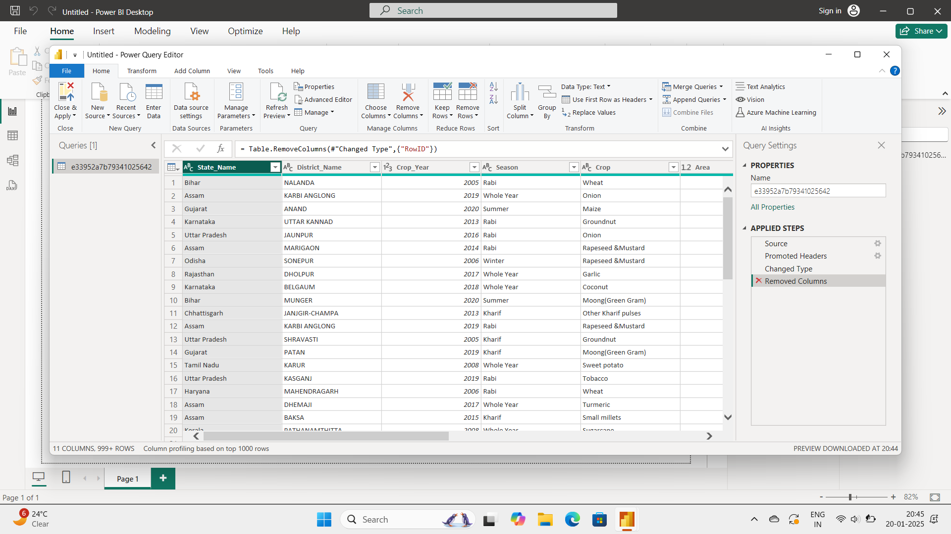

The column is back to its position.

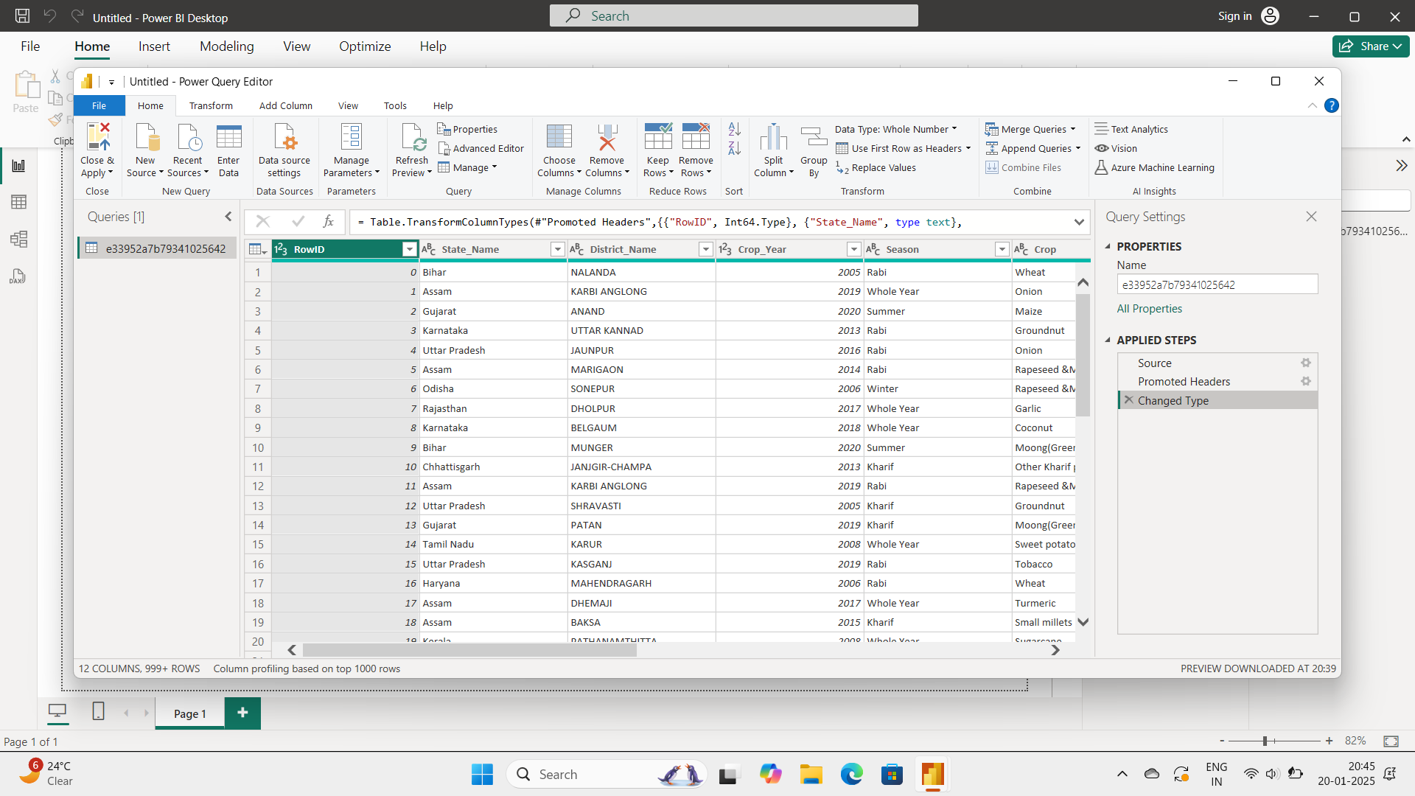

Similarly we have Remove Rows option. Inthat we can see three types .They are Remove duplicates, Remove blank rows , Remove errors.

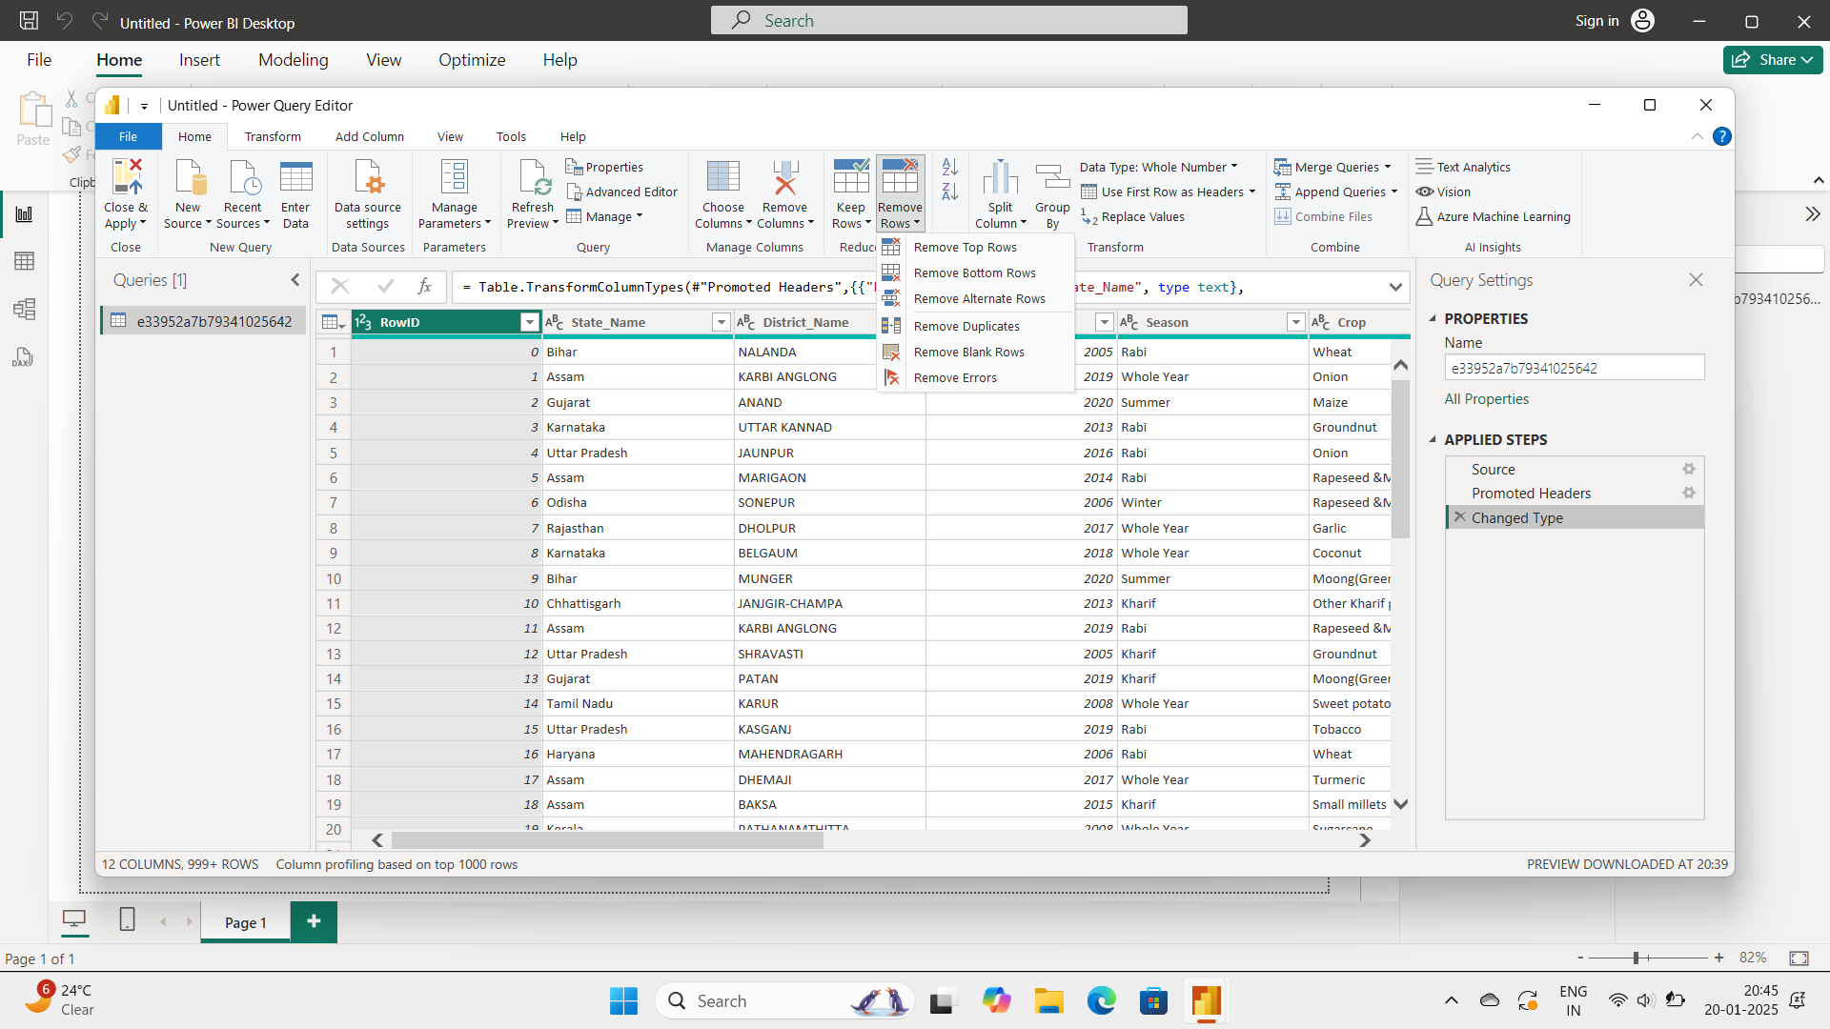

The remove duplicates option will remove the duplicates in the dataset which are already existed or similar data or copies of originals.

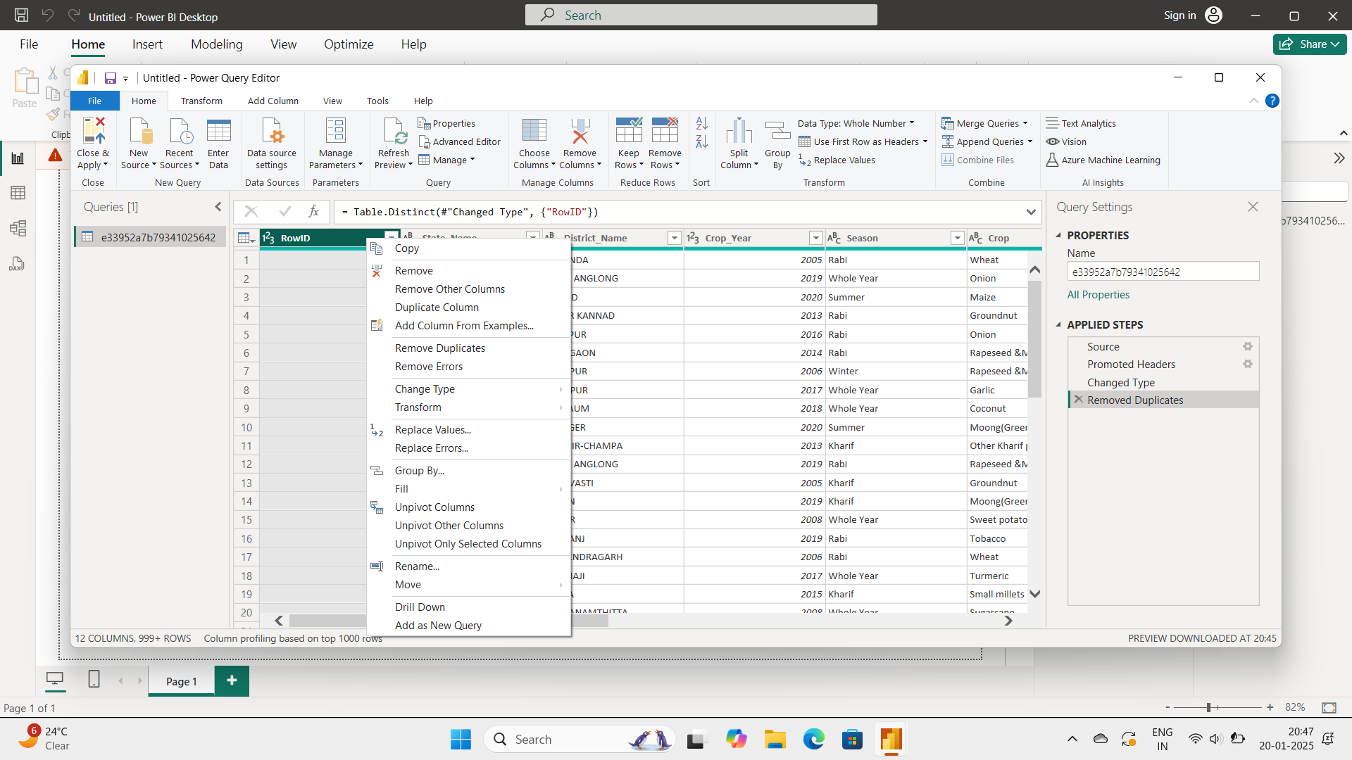

Here we can see different datatypes 123 and ABC which means numerical and alphabetical data types respectively.

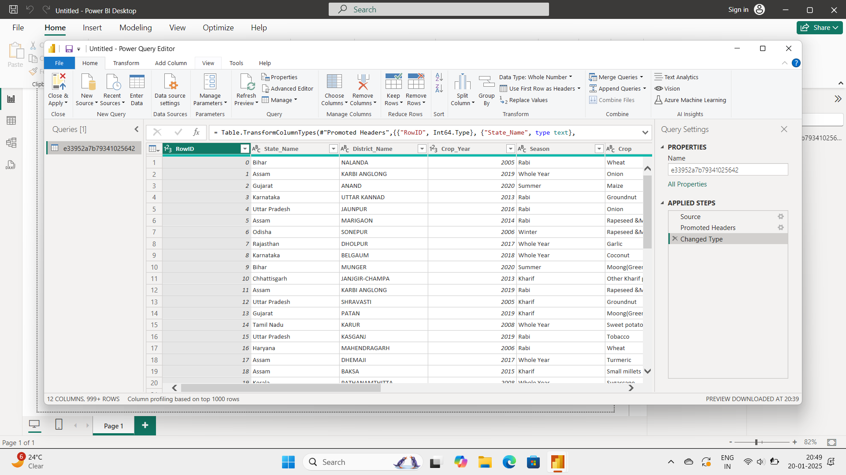

Next , click on view button.



By clicking on view , then it will show some options .

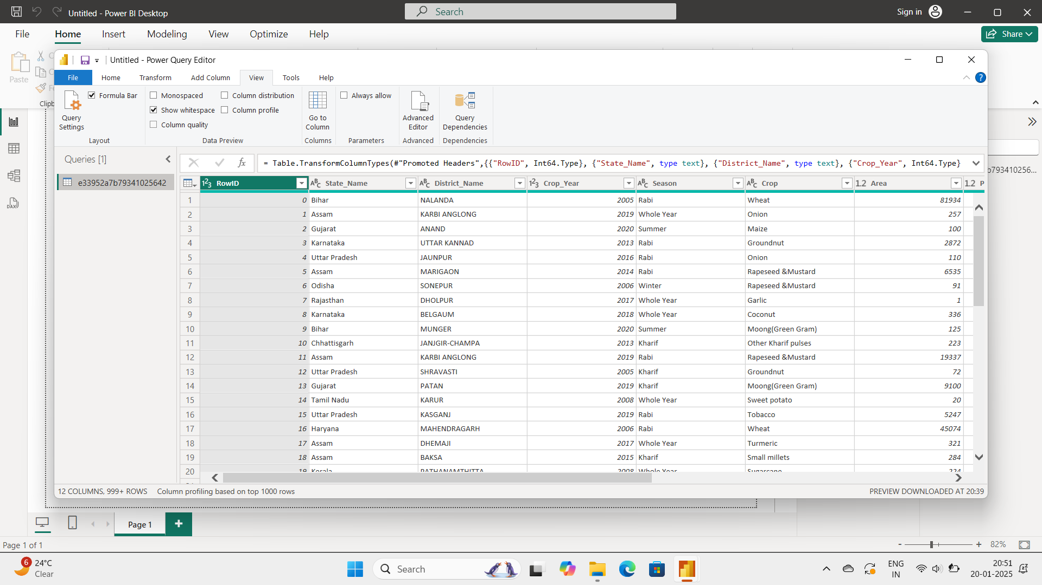

By selecting column quality , it’ll show the percentages of valid , Error and empty of every column.

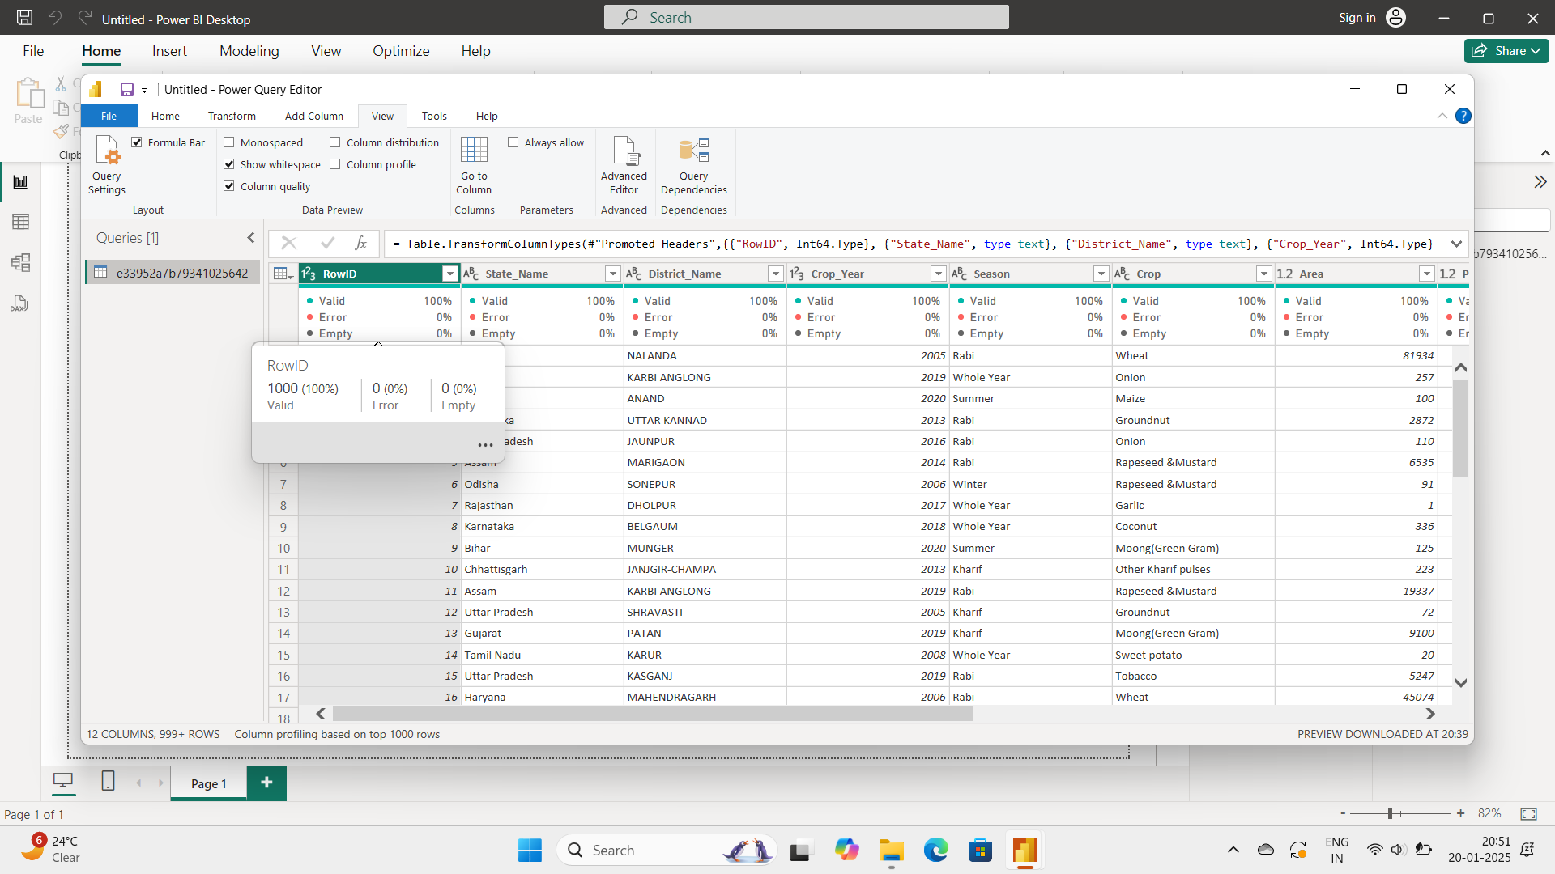

If we have any empty columns or errors or validilities , it will show more percentage on that status bar.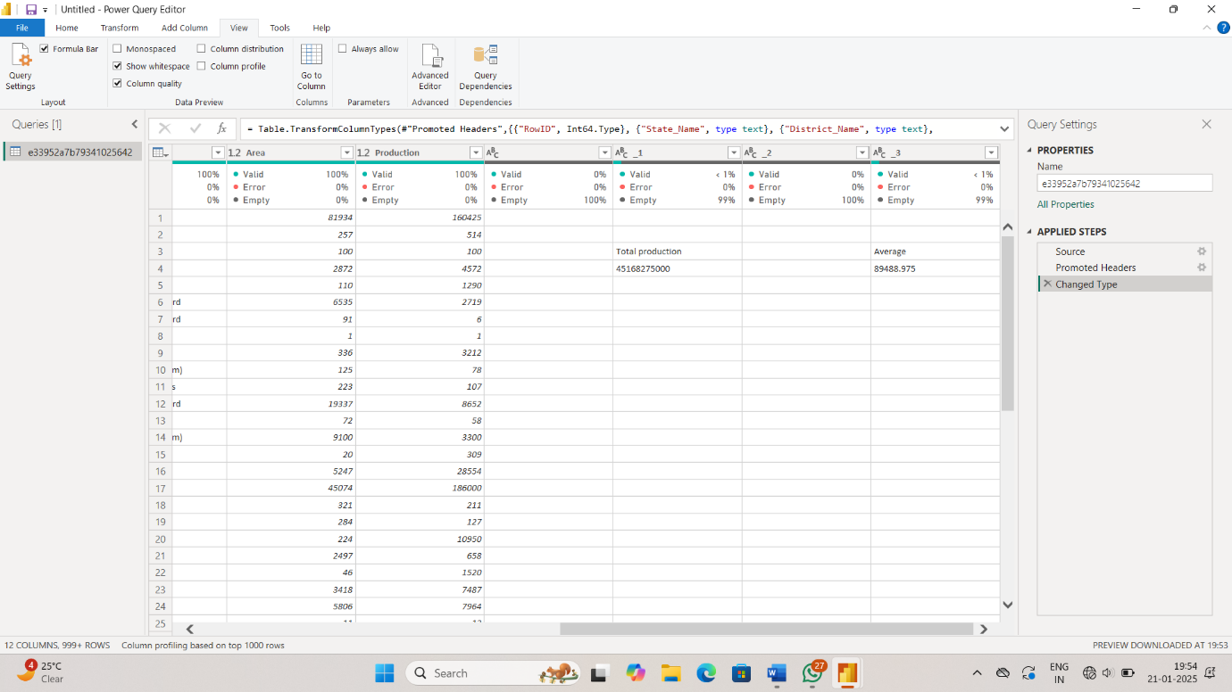

With this , we learn the basic features in Power BI Desktop.